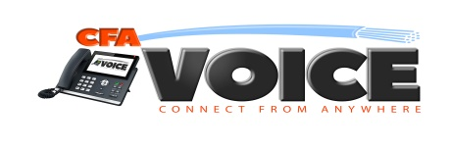

WEB CONFERENCING

Web conferencing, online collaboration, webinars and video-conferencing are some of the fastest growing segments of the communications industry. CFA Voice’s Web Conferencing solution enables us to offer cloud based web conferencing services to our business users. It is offered as a stand-alone service, or as an integrated part of our Hosted PBX solution.

Our Web Conferencing application offers a seamless user experience. Our unified sign-on system means that the same login name and password is used for PBX portal access and to start and access webinars, web conferences and remote-support sessions. The user experience will delight your customers and give their sales team another tool to attract and maintain customers.

Flexibility. The CFAVoice Web Conferencing solution bundles six real-time collaboration applications into a single desktop app that can be managed from the cloud:

- Web conferencing. Give sales presentations and product demos, and collaborate interactively
- Remote Support. Support PC and Mac users remotely
- Audio Conferencing. VoIP based audio conferencing
- Video Conferencing. Multi-point webcam video conferencing
- Webinar. Provide online seminars without download of any kind for view-only attendees

Scalability - Our customers can buy any number of rooms, any of which can accommodate up to fifty participants

Pricing - Our per room pricing allows you to pay-as-you-grow with no capital expenses and variable, predictable operating expenses.

